Admin Page

“Admin” link will be visible for Admin user(UserRoleId = 1) in top menu. When user clicks on Admin link, it will open Side menu as shown below. Side menu will have 5 different Sub menu. – User/Tournament/Match/Player/Auto Team

API Details:
Login: http://fanzania.com/FantasyCricketRest/api/fantasycricket/admin-sign-in
Promote User to Admin: http://fanzania.com/FantasyCricketRest/api/fantasycricket/admin-user-promote

Create/Update Tournament: (TournamentId is blank for Creation, non-blank for Update)
http://fanzania.com/FantasyCricketRest/api/fantasycricket/admin-update-tournament

Delete Tournament:
http://fanzania.com/FantasyCricketRest/api/fantasycricket/admin-delete-tournament

Calculate Points:
http://fanzania.com/FantasyCricketRest/api/fantasycricket/trigger-point-calculation
Fetch All Active Tournaments:
http://fanzania.com/FantasyCricketRest/api/fantasycricket/admin-fetch-tournament
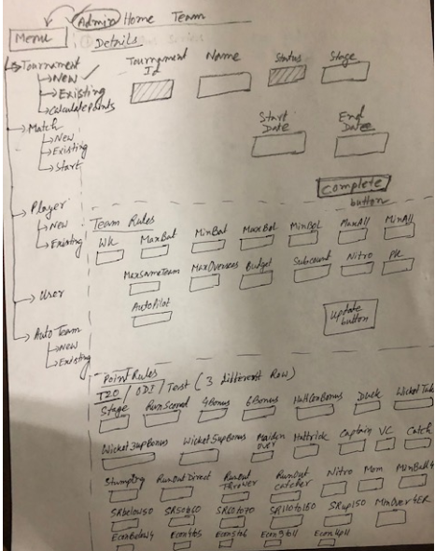
Tournament

Update Tournament Team Rules:
http://fanzania.com/FantasyCricketRest/api/fantasycricket/admin-update-tournament-team-rules

Fetch Tournament Team Rules:
http://fanzania.com/FantasyCricketRest/api/fantasycricket/team-selection-rule

Update Tournament Point Rules:
http://fanzania.com/FantasyCricketRest/api/fantasycricket/admin-update-tournament-point-rules
Fetch Tournament Point Rules:
http://fanzania.com/FantasyCricketRest/api/fantasycricket/admin-fetch-tournament-point-rules

Upload Participation Team:
http://fanzania.com/FantasyCricketRest/api/fantasycricket/admin-upload-participation-team

Update Participation Team:
http://fanzania.com/FantasyCricketRest/api/fantasycricket/admin-update-participation-team

Fetch Participation Team:
http://fanzania.com/FantasyCricketRest/api/fantasycricket/admin-fetch-participation-team

Delete Participation Team:
http://fanzania.com/FantasyCricketRest/api/fantasycricket/admin-delete-participation-team
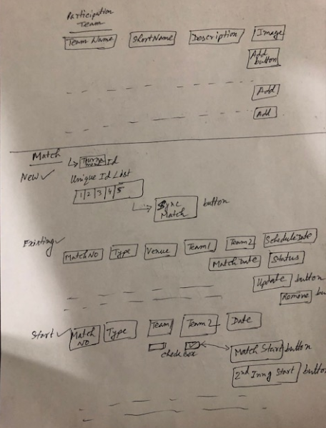
Match

Insert Match Details:
http://fanzania.com/FantasyCricketRest/api/fantasycricket/admin-insert-match-details

Update Match Details:
http://fanzania.com/FantasyCricketRest/api/fantasycricket/admin-update-match-details

Delete Match Details:
http://fanzania.com/FantasyCricketRest/api/fantasycricket/admin-delete-match-details

Fetch Match Details:
http://fanzania.com/FantasyCricketRest/api/fantasycricket/admin-fetch-match-details

Start Match:
http://fanzania.com/FantasyCricketRest/api/fantasycricket/start-match

Sync Match APIKey:
http://fanzania.com/FantasyCricketRest/api/fantasycricket/admin-sync-match-apikey

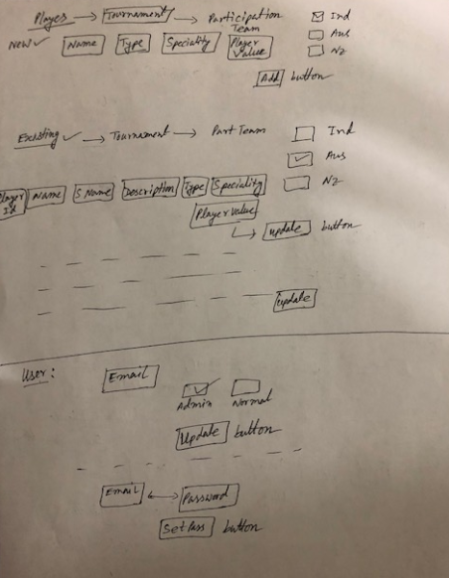
Player/User
Upload Player Details:
http://fanzania.com/FantasyCricketRest/api/fantasycricket/admin-upload-player-details

Update Player Details:
http://fanzania.com/FantasyCricketRest/api/fantasycricket/admin-update-player-details

Delete Player Details:
http://fanzania.com/FantasyCricketRest/api/fantasycricket/admin-delete-player-details

Fetch Player Details:
http://fanzania.com/FantasyCricketRest/api/fantasycricket/admin-fetch-player-details

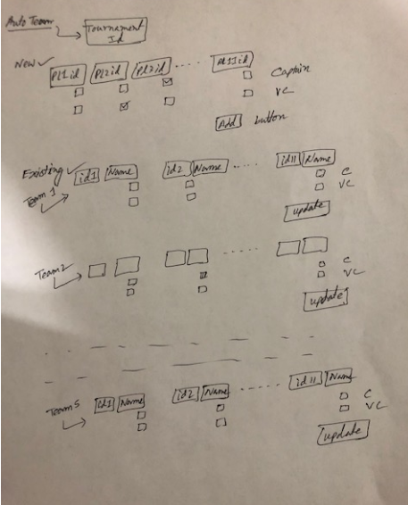
Auto Team

Update/Insert Auto Team:
http://fanzania.com/FantasyCricketRest/api/fantasycricket/admin-update-auto-team

Fetch Auto Team:
http://fanzania.com/FantasyCricketRest/api/fantasycricket/admin-fetch-auto-team

Delete Auto Team:
http://fanzania.com/FantasyCricketRest/api/fantasycricket/admin-delete-auto-team

